DBMS MINI PROJECT — REVIEW 1
MUSIC PLAYLIST MANAGER
Group ID | ____________________________
Mini Project Title | Music Playlist Management System
Division | SY BTech CSE CSF Panel A
Batch | A2
Team Members
Sr. No. | PRN | Name
1 | 1262252826 | Vedant Belsare
Problem Statement
Managing a music collection using separate playlist files can make it difficult to search songs, identify which playlists contain a song, preserve playlist order, and obtain useful information such as song counts and total playlist duration. The proposed Music Playlist Manager provides a relational database for storing artists, songs, playlists, and the relationships between songs and playlists. The system supports efficient retrieval and management of playlist information through SQL queries and database operations. A song may belong to multiple playlists, while its position within each playlist is preserved.
ER Diagram

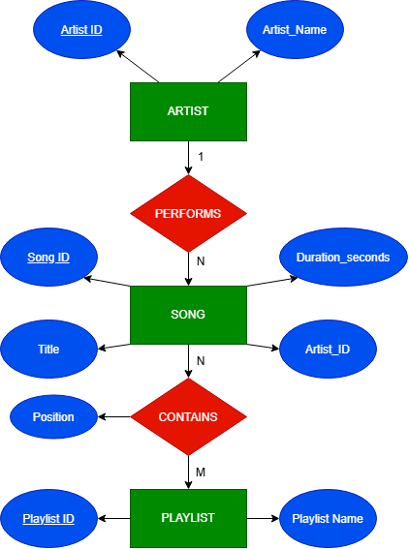
ER Relationships
- One ARTIST can perform many SONGs; each SONG is associated with one ARTIST.
- A SONG can appear in many PLAYLISTs, and a PLAYLIST can contain many SONGs.
- PLAYLIST_SONG resolves the many-to-many relationship and stores the song position within each playlist.

Schema Diagram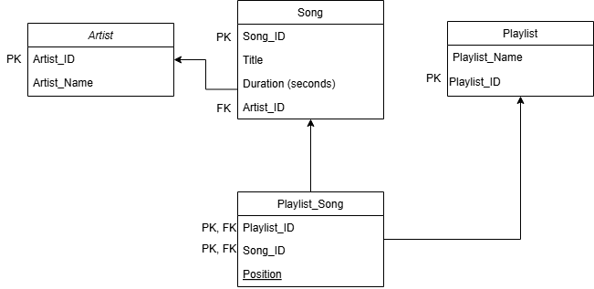
Schema Notes
- ARTIST → SONG is a one-to-many relationship.
- SONG ↔ PLAYLIST is a many-to-many relationship resolved by PLAYLIST_SONG.
- The composite primary key (Playlist_ID, Song_ID) prevents the same song from being associated with the same playlist more than once.
- Position preserves the order of songs within each playlist.
Team Member Signatures
PRN | Name | Signature
1262252826 | Vedant Belsare

